Linux Notes

1. The touch command's primary function is to modify a timestamp. Commonly, the utility is used for file creation, although this is not its primary function. The terminal program can change the modification and access time for any given file. The touch command creates a file only if the file doesn't already exist.The shell is the software we use to type the commands and view returned type text

Eg. Bash, Zsh, csh, fish and ksh.

1. Linux shell can be used remotely using softwares like SSH(Secure Shell)

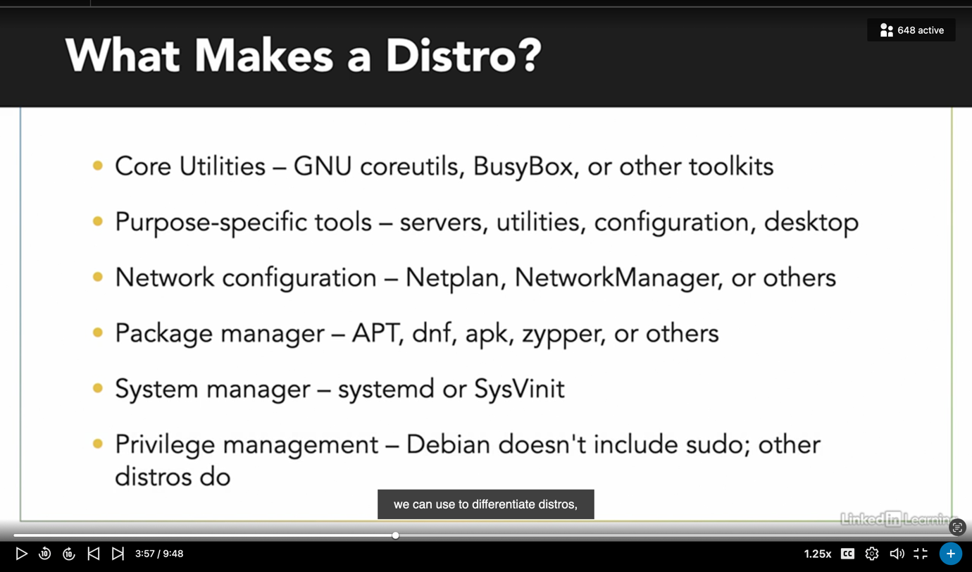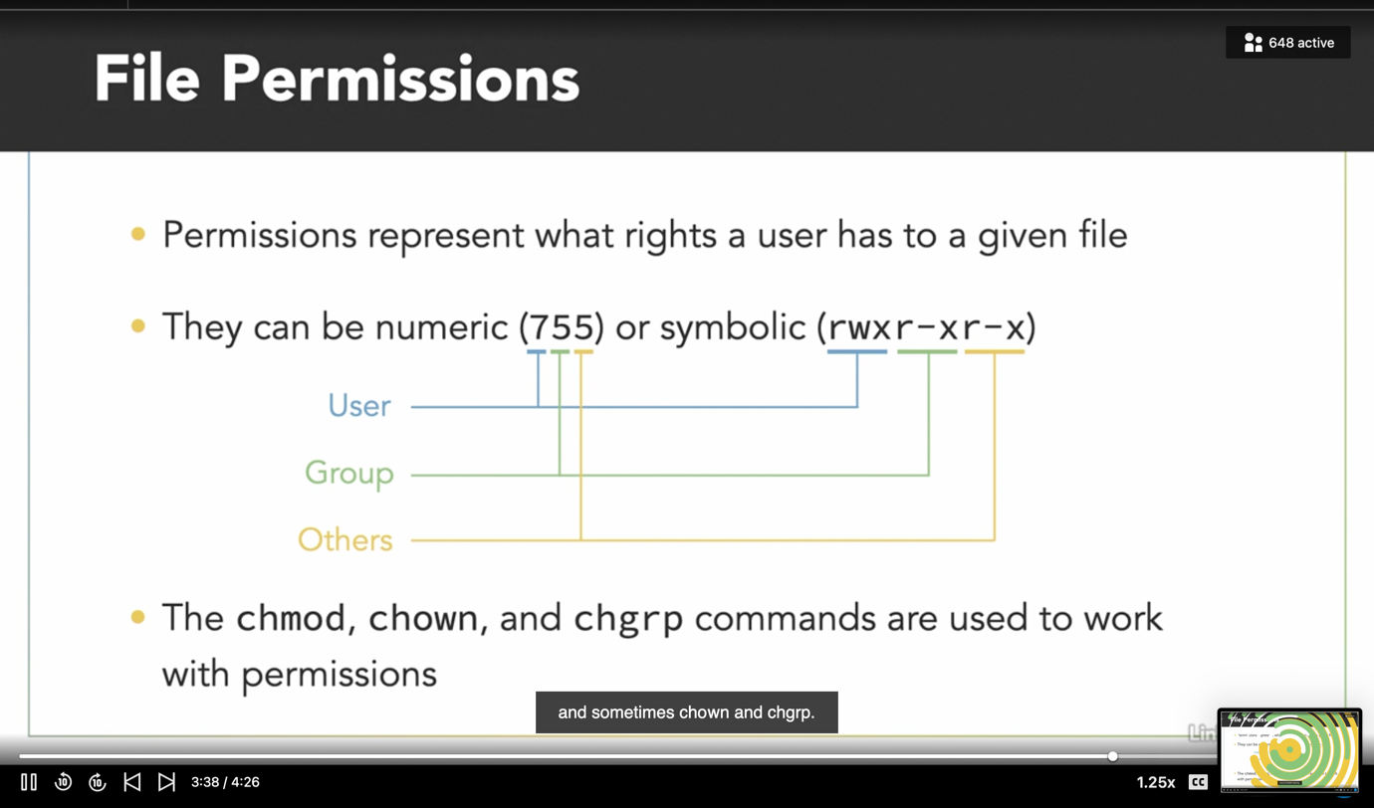

most common use of SED command in UNIX is for substitution or for find and replace. By using SED you can edit files even without opening them, which is much quicker way to find and replace something in file, than first opening that file in VI Editor and then changing it.

* SED is a powerful text stream editor. Can do insertion, deletion, search and replace(substitution).
* SED command in unix supports regular expression which allows it perform complex pattern matching.

RPM Package Manager (also known as RPM), originally called the Red-hat Package Manager, is an open source program for installing, uninstalling, and managing software packages in Linux.

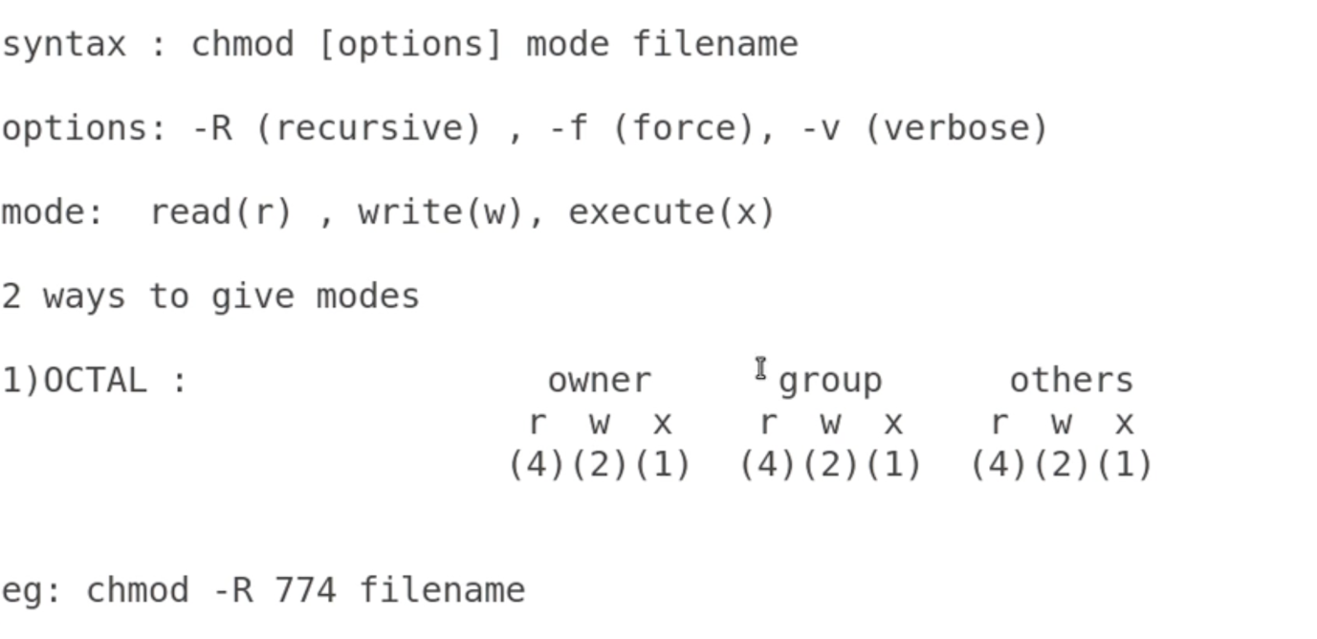

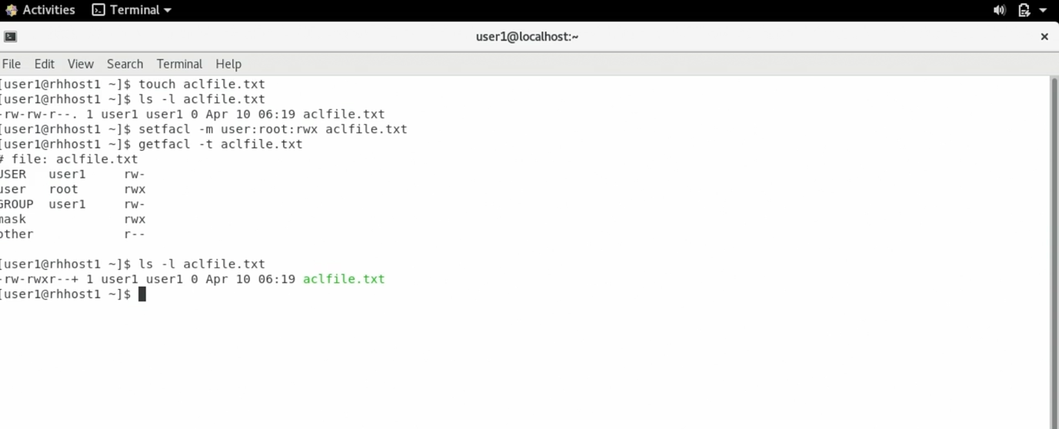

File globbing 🡪

Globbing is also known as path name expansion. To learn about file globbing first we need to know about **wildcards.**

**Wildcards**pattern are the strings containing characters like **'?', '[', '*'.** It performs action on more than one file having same pattern or to find part of a phrase in a text file. Shell uses wildcards for file globbing.

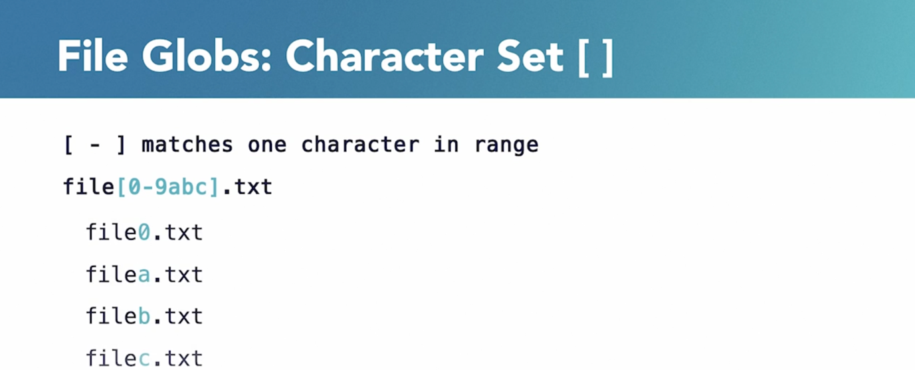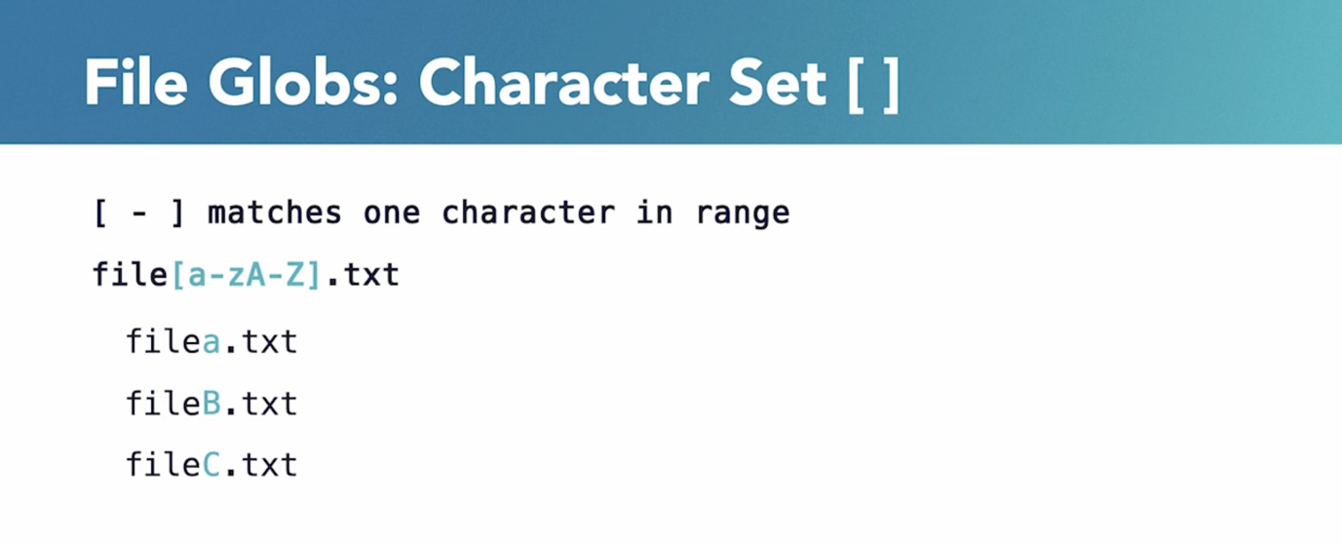**Globbing**is an operation that recognizes the wildcard pattern and expands it into its path name.

The above is used if we want ranges to include both uppercase and lowercase characters.

1. The asterisk is interpreted as the sign to generate matching file names. It is placed at the end of a line. It matches the combination by **any number of characters.**
2. ? question mark

You can also use question mark sign in place of asterisk to generate matching file names. It is placed at the end of a line. It matches the combination by**exactly one character**.

1. [] Square Brackets
2. Square brackets are also used to generate matching file names inside the brackets and the first subsequent. Order inside the square bracket doesn't matter. It m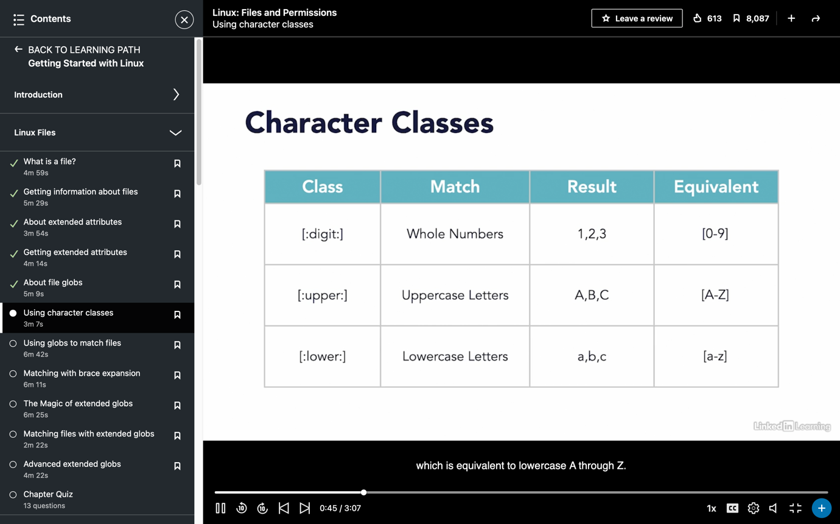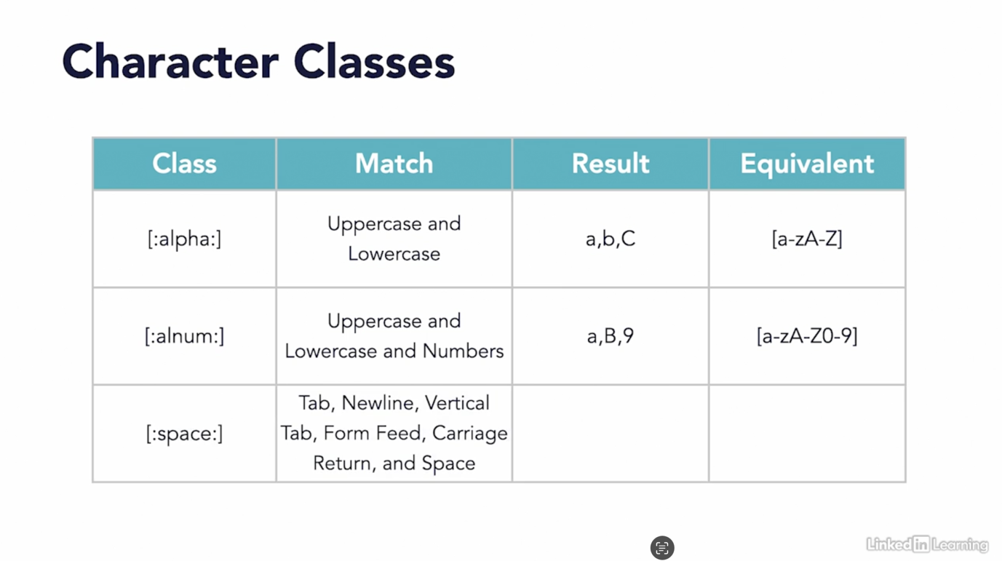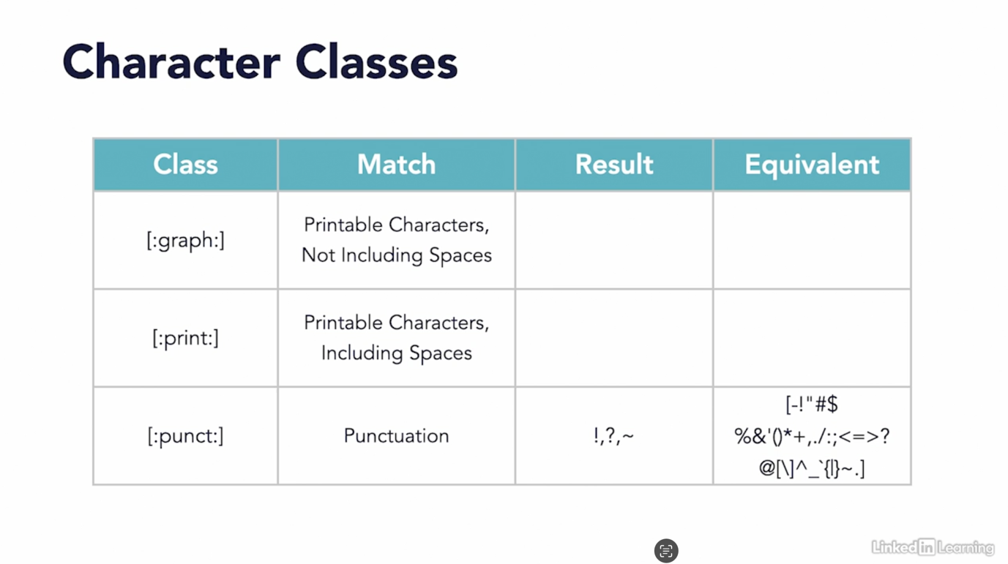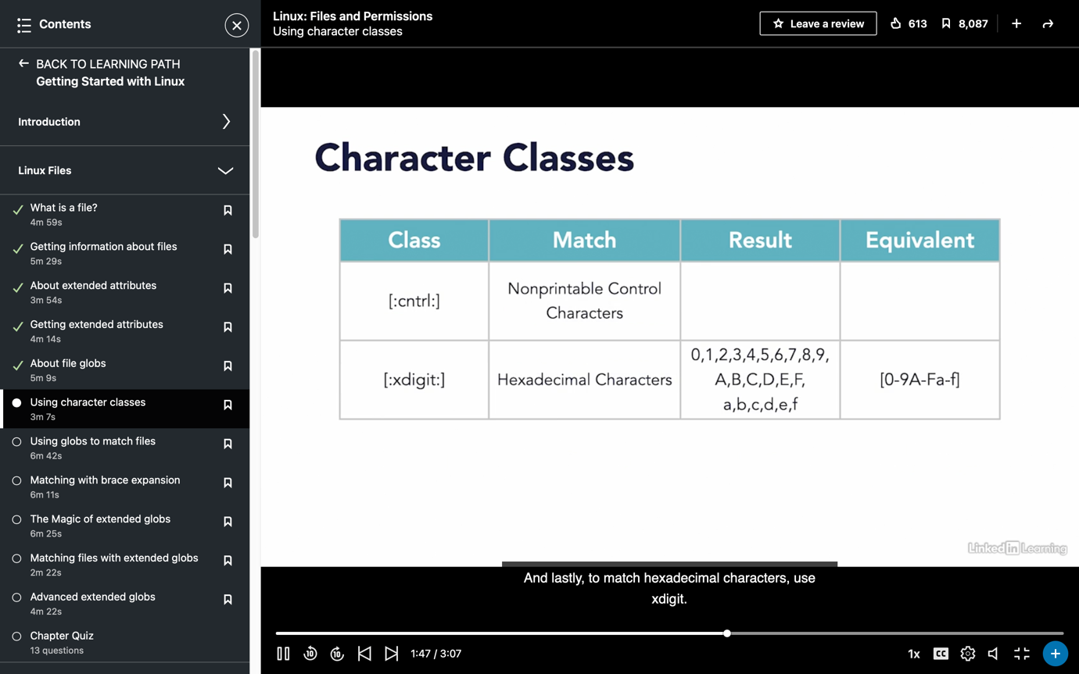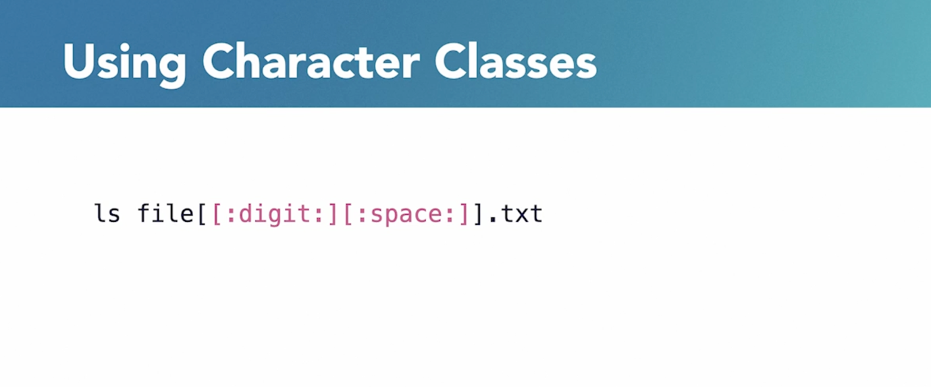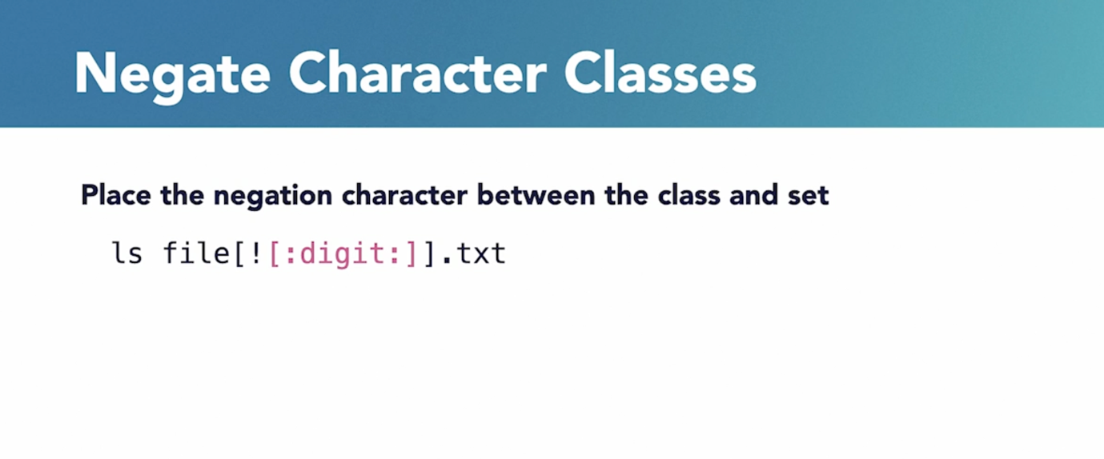atches the combination by exactly one character. 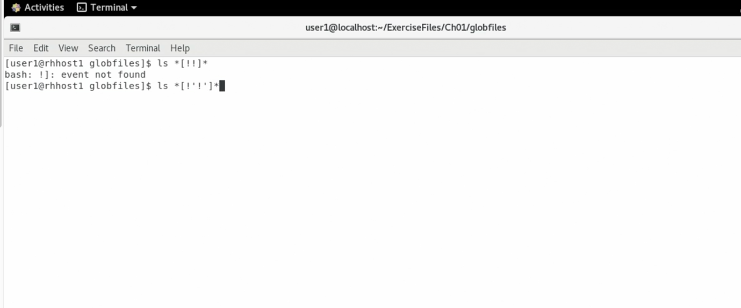Exclamation mark excludes characters from the list within the square bracket. And you can use the combination of asterisk 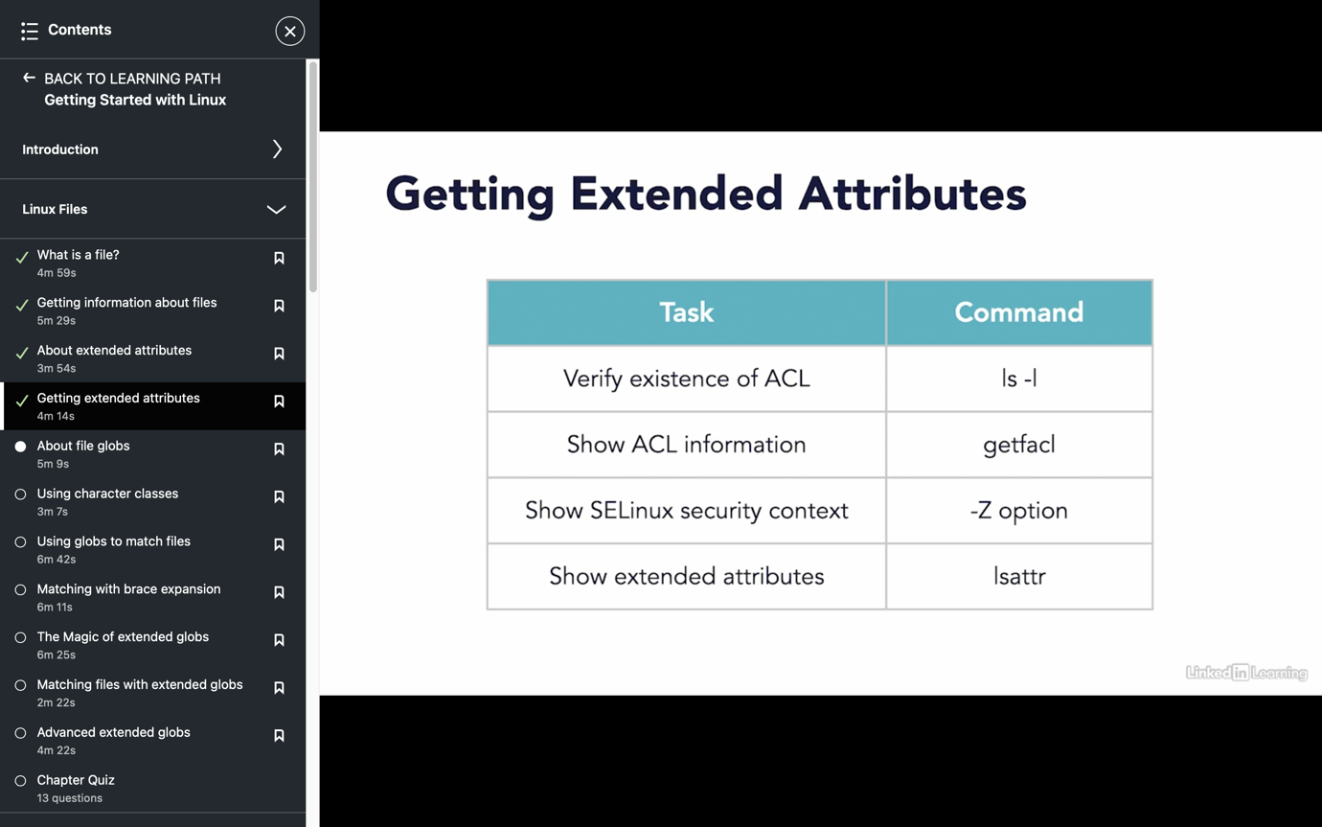(*), question mark (?) and square bracket [].ls office[a-z]

Chattr

The *chattr*command in Linux is a file system command which is used for changing the attributes of a file in a directory. The primary use of this command is to make several files unable to alter for users other than the superuser. As we know Linux is a multi-user operating system, there exist a chance that a user can delete a file that is of much concern to another user, say the administrator. To avoid such kinds of scenarios, Linux provides ‘*chattr*‘. In short, ‘chattr’ can make a file immutable, undeletable, only appendable and many more!

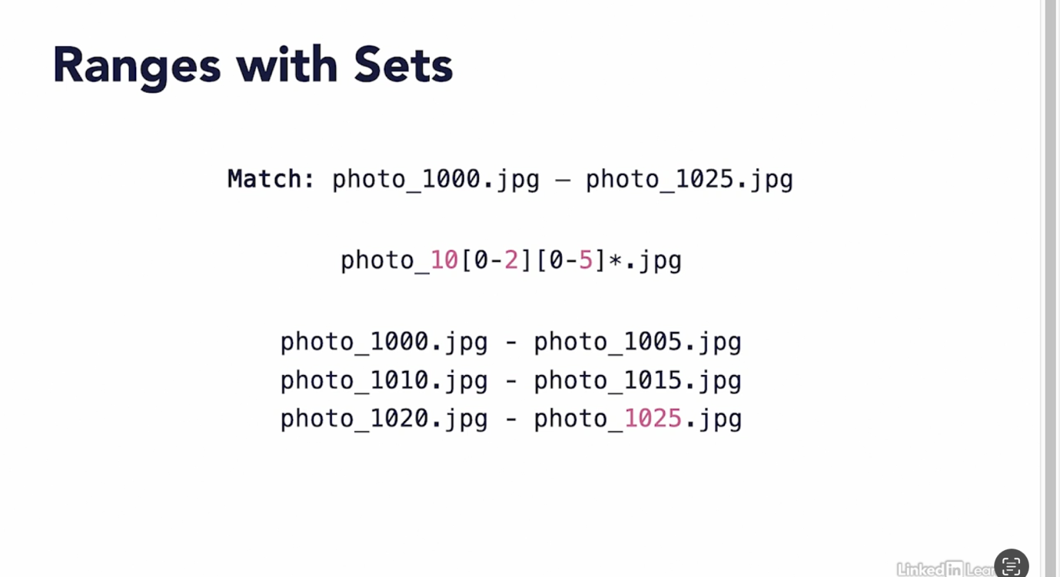Brace expansion

In this we want files from 1000 to 1025 but we cant get them by using [] . 10 files are missing. We can use {}. It can match multiple character while [] can match only one

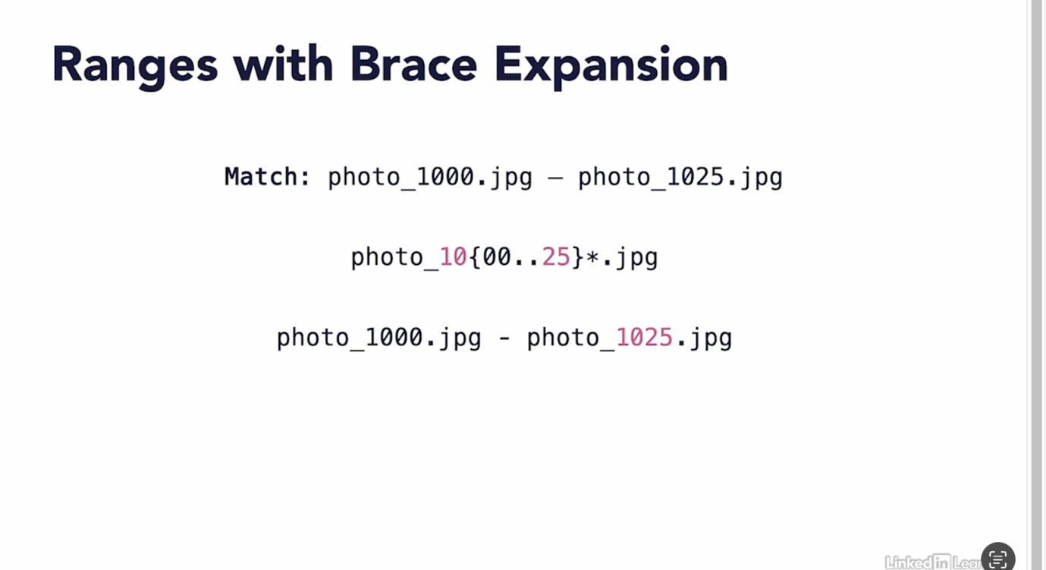

Increment

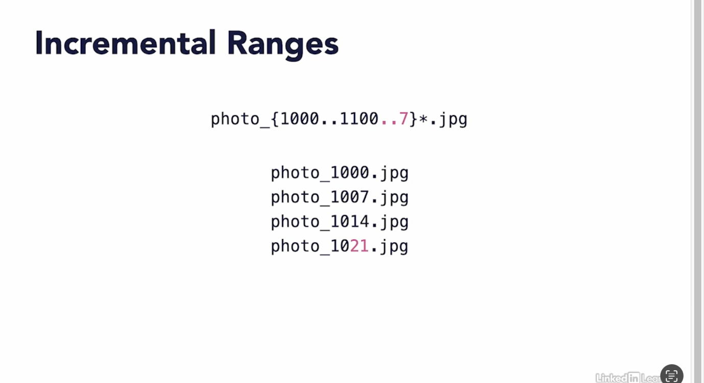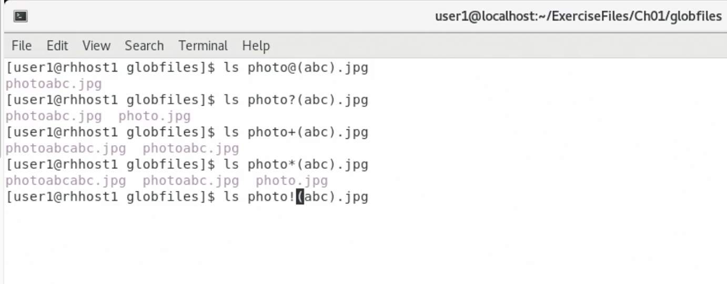

@ matches one occurrence of the string inside the brackets

? matches one or no zero occurrence

+ matches one or more than one

! matches without any occurance

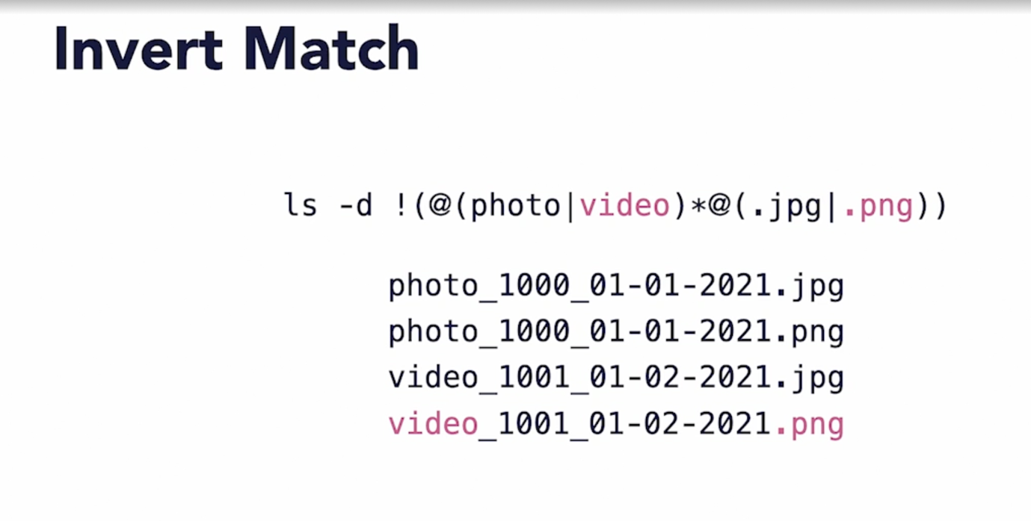

Chown 🡪 change owner of a file

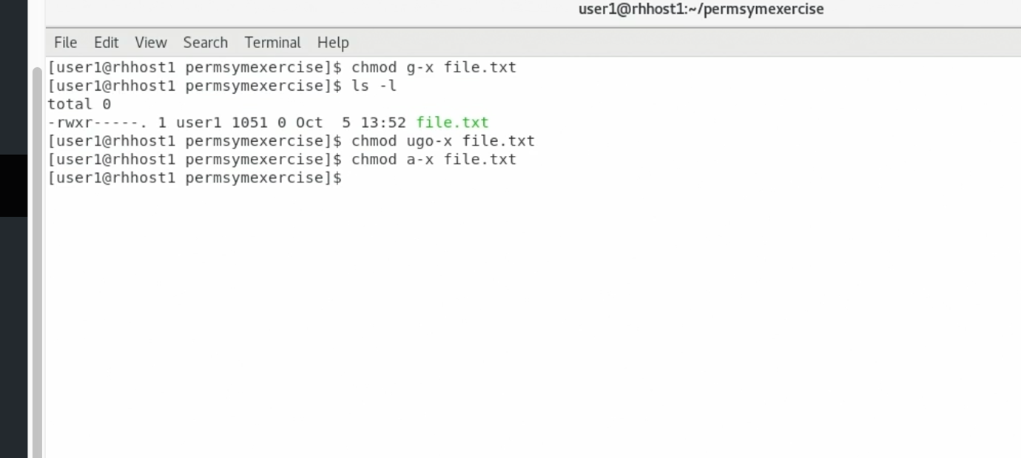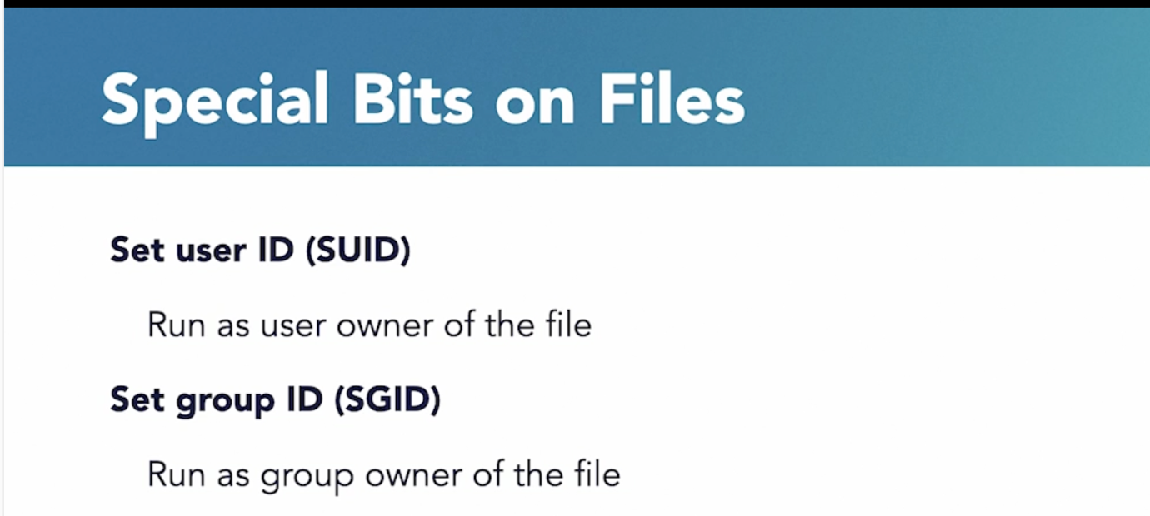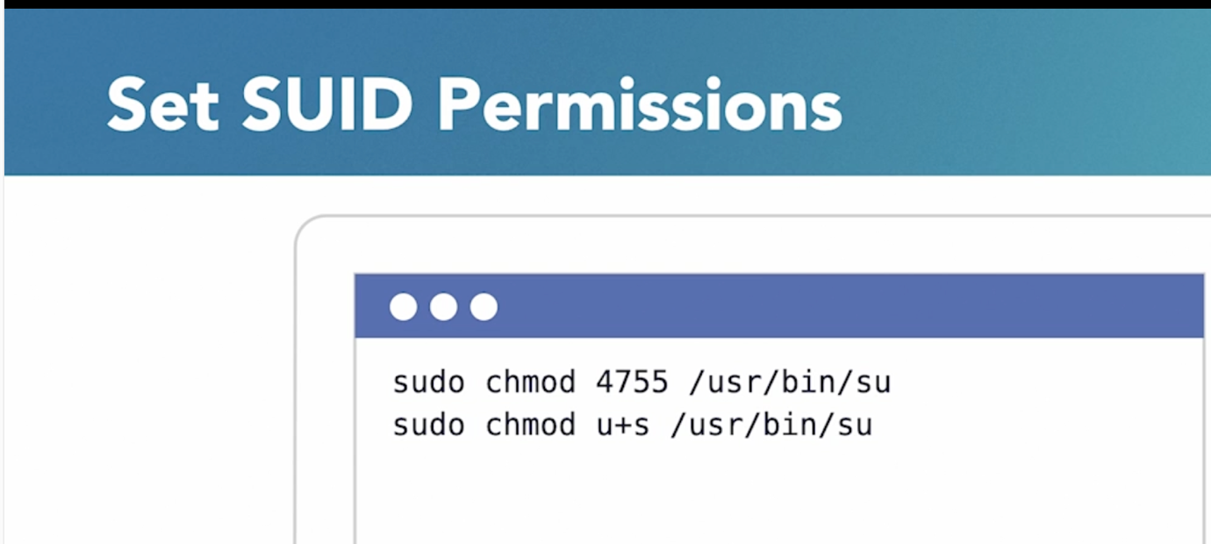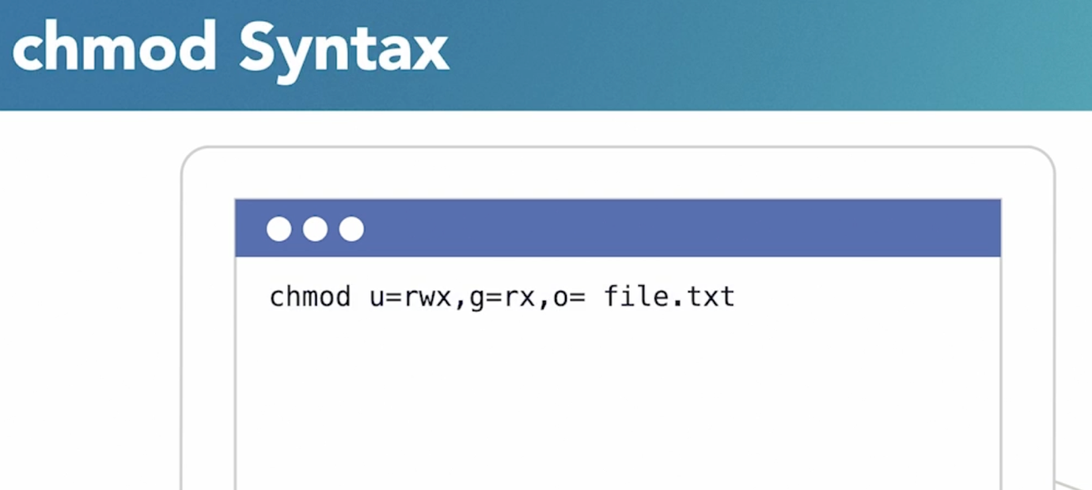

1. **Implicit Assignment:**
   * When permissions are assigned implicitly, it means that you indicate the changes you want to make without explicitly stating the current or exact permission values.
   * In symbolic mode, this often involves using symbolic representations and operators to add or remove specific permissions without specifying the numerical values.
   * For example, using **u+x** in symbolic mode implicitly adds execute permission to the owner without explicitly stating the current permission state.
2. **Explicit Assignment:**
   * When permissions are assigned explicitly, it means that you specify the exact permission values that you want to apply.
   * In numeric mode, this involves using numerical values to represent the read, write, and execute permissions for the owner, group, and others.
   * For example, using **chmod 755** explicitly sets read, write, and execute permissions for the owner, and read and execute permissions for the group and others.

